The Shelley Memorial Project

Commission of a public artwork as a memorial to the poet
Percy Bysshe Shelley

Artists Brief

The aim of the Shelley Memorial Project, (SMP), a community group made up of individuals and local community organisations from Horsham, is to achieve a lasting public memorial to the poet Percy Bysshe Shelley. The memorial will celebrate and commemorate ‘the most eminent person to whom Horsham can lay claim’, and his works. The intention in delivering this memorial is not only to celebrate the achievement of a major literary figure from the Horsham community, but also to:

- Provide literary, historical and philosophical inspiration to Horsham residents and visitors,
- Highlight Horsham’s place in our country’s cultural and historical heritage,
- Represent and inspire the talent within our community, with a particular emphasis on young talent as represented by Shelley’s phenomenal body of work, achieved in his young life.

There is an expectation that the selected design will result in a work of art that is in harmony with its setting. It should address as far as possible the aims set out above in order to provide a pleasing and inspirational cultural experience for those living and working in or visiting Horsham. The artwork will become a key feature, a landmark for generations and add to the quality and attractiveness of Horsham Park.

The Shelley Memorial Project has allowed a budget of £ 70,000. plus VAT for the realisation of the commission. A Steering Group will oversee the process of selection of the artwork that will be commissioned for the memorial. This will be made up of representatives from the SMP and representatives from Horsham District Council who own the site on which the memorial will be installed.
At the conclusion of the initial application stage, four artists will be selected to take part in an open competition for the commission in response to this brief.

Maximum Value of Commission £ 70,000 Plus VAT

CONTENTS

- Background ………………………………………………………… 2
- Theme ………………………………………………………………. 2
- History …………………..…...……………………………………… 3
- Location of Work……………………………………………..…….. 3
- Scope of the Work…………………………………………………… 4
- Technical Guidelines ……………………………………………….. 5
- Artistic Opportunities……………………………………………… 5
- Application Process…………………………………………………. 5
- Outline of the selection Process …………………………………. 6
- Planning and approval Requirements……………………………. 6
- Selection Process from shortlisting to selection of
final design …………………………………………………………7
- Role of the commissioned artist…………………………………... 8
- Installation ……………………………………………………………. 8
- Managing the Commission ………………………………………... 9
- Commissioning Agency …………………………………………… 9
- General ………………………………………………………………. 10
- Project Timeline..………………………………………………… 10
- Appendices ………………………………………………………... 11

Back Ground
In 2018, as a renewed focus on Horsham’s cultural heritage developed with preparations for Horsham’s Year of Culture in 2019, the Shelley Memorial Project (SMP) was formed. The purpose of its formation was to achieve the objectives set out at the start of this document. The SMP group consists of individuals and community groups from Horsham with an interest in Percy Bysshe Shelley; a towering cultural figure and our local poet. The project aims to deliver its objective of commissioning an artwork as close as possible to the 200 year anniversary of the poet’s death. This anniversary will bring a national and international focus on our poet.

All individuals and representatives of the groups involved give up their time voluntarily to achieve the aim of delivering a permanent, public memorial to Shelley. We believe that this will be the only public memorial to Shelley in the country.

Theme
The theme of this cultural project is the celebration of the life and work of Percy Bysshe Shelley, who was born a short distance from Horsham into a family with very strong local connections. The connection with our town of a young person of exceptional talent, who

produced in his short life a vast body of work including poetry, social and political commentary and reflection on natural science, should be a source of inspiration to Horsham residents; particularly young residents, in view of the quality and breadth of work produced. Through that local connection and the identification with a local person of such renown, we hope others will have a sense of what they, too, can achieve. The memorial should also provide a source of inspiration and interest to visitors to our town who will gain a greater awareness of Shelley, the person behind the great talent, and of his background. The artwork should seek to engage the widest audience possible and also inspire younger people and new generations to come.

History
Percy Bysshe Shelley was born in Field Place in Warnham, a small village close to Horsham. Shelley is one of the major English Romantic poets and is internationally known as one of the most influential poets in the English language. His fame and its enduring nature is particularly remarkable in view of his early death in 1822 at the age of just 29. His writings are said to have influenced an impressive list of key figures in literature, philosophy and politics including; Thomas Hardy, George Bernard Shaw, WB Yeats, Clement Attlee and even Karl Marx! His work is studied, admired and referenced widely in modern times. Shelley is undoubtedly a towering cultural figure and yet, in Horsham District, where he was born, there are very few references to the most famous person to have been born here. Furthermore, we do not believe that there is a public memorial to the great poet anywhere in the country.

In 1996, shortly after the bicentenary of Shelley’s birth, and in response to a call for a permanent memorial to Shelley, a sculpture by Angela Conner, entitled ‘Rising Universe’ was installed in Horsham town centre This artwork was a kinetic water sculpture which came to be known as the Shelley Fountain. It featured a large globe that filled with water as it rose and fell. Maintaining the artwork in working condition became expensive and, as a result, the sculpture, in more recent years, rarely operated as intended. This increased the controversy around the sculpture which met with a mixed reaction from local people following its installation. Some found it ugly in appearance and failed to see clearly the connection with the poet. Others were more appreciative of the artwork but were unhappy with the frequency with which the mechanism seemed to require maintenance to keep it in working order. For some time before its eventual removal in 2016 it was not in a working state.

The Shelley Fountain was not loved by all and, for reasons not connected to Shelley’s literature, became a fairly controversial installation. Whilst it was in place, however, it did achieve some of the positive objectives that memorials represent. Since its removal many people have expressed a wish for a replacement that will reconnect the town, clearly and appropriately, with our poet and provide an appropriate memorial to the poet and his work

Location of Work- Horsham Park ‘Circus’
Horsham Park is the town’s principal green space and has been recognised for the second year running by the prestigious international Green Flag Award Scheme as one of the best green spaces in the UK. It is close to the town centre and surrounded by residential and office buildings. It is a key area of public activity in the town, with sports and children’s play facilities set in a large open space. There is a pond, some formal horticulture and traditional park land with trees and large open grassed areas. It is a very large open space and well used by local people.

At the centre of the park, next to the pond, the paths that cross the park meet in a large ‘circus’ area. These paths are frequently used as a short-cut through the park from Hurst Road and the Richard Collyer School to the town centre. At the opposite end of one of these paths is the Park House, the former home of the Hurst family which is now used as offices. Either side of the path that runs from the house to the circus a row of Fastigiate Oak, creating an avenue along this stretch of the path.

The memorial should be located in the centre of the circus as far as is possible and, to all intents and purposes, at the centre of the park, emphasising the centrality of Shelley’s position in the cultural history of our town.

Consideration should be given to an appropriate scale. The site being centrally located and at the confluence of a number of intersecting paths, should provide sufficient space to realise an artwork of sufficient comparable scale and presence.

Consideration should also be given to how the memorial can most easily engage in this setting with the themes of the romantic and radical poetry for which Shelley is best known.

Scope of the work
The purpose of this commission is to design and create a memorial that will celebrate Percy Bysshe Shelley as a great and inspirational literary figure, and a citizen of Horsham. His connection with our town should inspire its citizens and connect our town firmly within the cultural history of our country.

Within the context all of the above, the artists will be asked to consider the following factors:

- Iconic and high quality design in a non-representational, abstract or representational sculptural form.
- The spirit/essence of Shelley and his work with particular reference to his contribution to the Romantic era and radical philosophy.
- The artwork should convey something about the role of art in society today.
- The artwork should enhance and connect with the environment and,
- Should have a low carbon footprint.

Consideration should also be given to:
- Lighting.
- The nature of the public realm – constraints and opportunities.
- Durability, maintenance and vulnerability to vandalism.
- Relevance to current and future communities in the town.
- Enhancing the cultural experience of the public.
- Seasonal changes – the materials used must be robust enough to withstand the various weather conditions that exist within the English climate.
- Installation costs.
- Construction design management (CDM).

Technical Guidelines
The artwork must:
- Take into consideration planning and site requirements.
- Not raise security or safety issues nor inhibit public access.
- Be easy to maintain.
- Be made of materials robust enough to withstand normal wear in a public place and produced in such a way that future maintenance and repair is possible.
- Consider weight and installation requirements (notionally considered at this stage)
- Be aware of the positions of statutory services, foul sewers, within the vicinity of the ‘circus’.

In addition:
- Final siting and design must be approved by Horsham District Council.
- The artist is required to provide a maintenance manual at completion of the work.

Artistic Opportunities
Artists should consider the scope for a three dimensional intervention in response to the space. Artists will need to consider the relationship of surfaces, materials, textures and tones; and/or the potential for lighting the artwork. It must be stressed that at this initial competition stage artists are asked to come up with a ‘big idea’ – a broad brush approach to the scheme. The selected artists will then be invited to develop ideas in further detail, to a point where the Group and Council can satisfactorily carry out public consultation.

Application Process.
Please send your application in a digital form with 1 hard copy including:

- A letter of application, which outlines why you are interested in this project, your experience of this type of work and how you would approach the commission. We would expect to see at this stage details of the broad brush approach mentioned above, with reference to the factors set out under ‘Scope of the Work’ and the objectives that we have set out in the introduction to this document. (Max 3 page)
- Up to 3 examples of relevant work you have completed including descriptions and images (all images must be presented in a PowerPoint presentation). Please outline the costs and timescales of the project. (Max 1 page, )
- Other supporting information – (please limit to 8 images, 2 sides of A4 or equivalent.)
- Current CV.
- Details of two referees.

Please note, all submissions will be kept on file and will only be returned to the applicant on request.

Please send the above application pack to: shelleymemorialproject@btinternet.com and David Hide, Chair, The Shelley Memorial Project, 10 Clarence Road, Horsham, RH13 5SQ and .
The deadline for submission of applications is 30 January 2023

Outline of the selection Process

From the submissions the Steering Group will short-list four artists to develop their ideas further in line with the set criteria.

The Steering Group:

- David Hide Chair of the Shelley Memorial Project and 3 other members of the project committee.
- Three representatives from Horsham District Council- The cabinet members for Culture and Leisure, Horsham Town and the Head of Culture and Leisure.

Each of the shortlisted artists will be invited to attend a briefing session with questions and answers with the members of the steering group and other stakeholders including site manager on 15 March 2023 or (another mutually convenient date) to view the site. Each of the artists will then develop detailed site specific proposal for presentation to the steering group on 15 May 2023 (or another mutually convenient date).

Following the artist’s presentations at the end of the design period, the Steering Group, together with the Council, will carry out public engagement to seek wider views in the merits of each of the proposed artistic approaches.

Following the engagement process the Steering group will consider all views and announce the chosen design. One of the artists will be selected and, depending on planning permission being gained and the fundraising target being successfully achieved, will be commissioned to carry out the agreed work of art.

It is expected that the design process will be interactive with opportunities for the artist to discuss ideas as they emerge with the steering group and relevant site managers.

Planning and Approval Requirements
The selected artist and representatives from the Shelley Memorial Project may need to attend a pre-application meeting with Horsham District Council prior to lodgement of a planning application. The Shelley Memorial Project will prepare the planning application document with the assistance of the artist. The project will only proceed if planning approval is obtained. The Shelley Memorial Project will cover the costs associated with planning approval.

The artist may be required to attend a number of meetings with planners and stakeholders in Horsham during the course of their contract, to present and discuss their designs. The artist will work primarily with The Shelley Memorial Project and stakeholders involved with the landlord of the site.

Selection process from shortlisting to selection of final design.

Stage 1 Shortlisted artists site visit and information session.

Shortlisted Artists will meet with the Steering group for a ½ day briefing which will enable them to get a better understanding of the project, and a chance to ask any questions

Stage 2 Concept designs
Shortlisted artists will receive a fee of £400 + VAT to prepare a bona-fide concept design, detailed budget and attend an interview with the Panel to present the design. The fee is to cover all expenses associated with designing and presenting the concept (including travel and accommodation).

Shortlisted artists will develop concept designs which will be presented to the Steering Group on 15th May 2023 (or another mutually convenient date).

The presentation should address the following selection criteria:
- Drawings or photomontages or computer generated images indicating the proposed work in situ
- Model or maquette of the proposed artwork/s
- A photograph and/ or other visual media to be used as part of the public consultation process
- Written statement describing the artistic aims of the proposal
- Indicative timescales for design, production and installation.
- Outline budget indicating the commission proposal is feasible within the sum of £ 70,000 plus VAT with a breakdown of costs covering:

1. Overall commission design and engagement fee.
2. Production fees and costs.
3. Installation fees and costs.
4. Maintenance costs.

Stage 4 Community Engagement
The Council and the Shelley Memorial Group will carry out public consultation on the four shortlisted concept designs which may include a voting process on an order of preferences.

As part of the public consultation process, maquettes of the artist’s proposals will be on display at a location to be confirmed within Horsham Town Centre. The panel will then decide on an artist who best meets the selection criteria, who will be invited to proceed to the final stage.

The consultation is aimed at engaging Horsham residents and stakeholder groups in the process of selecting an appropriate artwork, and testing overall acceptability and impact. It is important that the public both locally and regionally are engaged in a positive way to ensure:

- There is broad acceptance of the eventual chosen artwork;
- A wider sense of ownership; creating a sense of pride and raise awareness and appreciation of Horsham Park and the locality.
- A means by which the community can engage over its environment.
- Promotion and awareness of Shelley’s work and cultural significance

Stage 5 Selection of Final Design

Selection Criteria

1. Design
- Quality of concept
- Quality of proposal in addressing the various factors outlined in the Scope of the Work and Technical Guidelines
- Innovative ideas and approach
- Realisation in existing work

2. Community Engagement
Reflection and consideration of the results of the community engagement with the public and stakeholder groups.

3. Project Management / Public Art Experience.
The artist should demonstrate planning and management skills through having completed a public art commission or a project on a similar scale.

3. Communication Skills
The artist should demonstrate an ability to clearly express the design ideas in drawings and plans.

4. Budget
The artist should provide an indicative budget for their proposal.

The panel will decide on an artist who best meets the selection criteria, who will be invited to proceed to the final stage.

The Shelley Memorial Project will announce the selected artist in July 2023

Stage 6: Planning Permission & Legal Agreement
The artist in collaboration with the Steering Group will seek planning permission for the artwork from Horsham District Council as the local planning authority.

The artist will be required to enter into a legal agreement with the Council

Stage 7: Commission Implementation
The Steering Group and the artist will agree the final fee for the commission. The commission fee shall include all aspects of the design (including artist fees, workshops, travel, accommodation and meetings), fabrication and installation of the artwork and all other professional fees (subcontractor, structural engineer etc., as necessary).

Payment up to the agreed fee will be made on receipt of invoices to be submitted to Carol Hayton Treasurer, The Shelley Memorial Project, 10 Clarence Road Horsham, RH13 5SQ.

The Steering Group will agree a suitable payment schedule with the artist such as:

1. One third to be paid at Commission Start following conclusion of the legal agreement and receipt of planning permission.
2. One third to be paid, at a point to be agreed, when production is suitably advanced, to allow the Steering Group to review progress and request any possible ‘minor’ changes before committing to final production and installation.
3. One third to be paid following satisfactory installation of the artwork and completion of all works.

Role of the Commissioned Artist

The commissioned artist will be contracted by the Shelley Memorial Project to:
- Prepare presentation drawings to convey the design including plan views and elevations.
- Provide design documentation for fabrication and installation including specification, plans, elevations, construction details and fabrication/installation notes as required (drawings should be to scale, describe intended colours and materials, and be suitable for submission for the planning permission).
- Provide a final design report including an artist’s statement describing the proposed works and an itemised budget.
- In collaboration with the Shelley Memorial Project seek Planning Permission for approval for the artwork with Horsham District Council.
- The artist will be expected to liaise with the council as landlord and site managers and attend appropriate meetings with relevant stakeholders to ensure the safe delivery and installation of the artwork.
- Upon receiving Planning Permission and conclusion of a legal agreement, procure materials, fabricate and install the work
- Project manage production/fabrication, delivery and installation.
- Foundation/base design.

Managing the Commission
For the installation of the artwork the artist is encouraged to work with a contractor experienced at installing electrical works if these form part of the artwork. Any sub-contractors employed by the artist to assist with fabricating and/or installing the work must be accredited professionals and be paid for from the commission fee. The artist’s budget would need to reflect this

Commissioning Agency
The Steering Group of the Shelley Memorial Project will commission the artist and the artist will report to them. Upon installation the artwork will become the property of the council who will hold it in trust for the community of the Horsham. The Council will be responsible for its maintenance and insurance.

General
The Shelley Memorial Project reserves the right at any stage not to proceed with the project, or to proceed on a different basis from that anticipated in this document. No contractual or other legal obligation arises on the part of the Shelley Memorial Project from the lodgement of an application to this process. The selected artists will be required to sign a contract with The Shelley Memorial project.

Project Timeline

STAGE | ITEM | DATE
1 | Deadline for Applications | 30 January 2023
2 | Shortlisted Artists’ Site Visit and Information | 15 March 2023
3 | Concept Design Presentation | 15 May 2023
4 | Community Engagement | May 2023 to June 2023
5 | Selection of Final Design | July 2023
6 | Planning Permission & Legal Agreement | TBA
7 | Commission Implementation | TBA
Inclusions

Appendices – Plans of Location of Commission

Further information
For further information please contact, Carol Hayton, Secretary, Shelley Memorial Project on 01403 241695 or email : carolhayton@btinternet.com
Horsham Plan

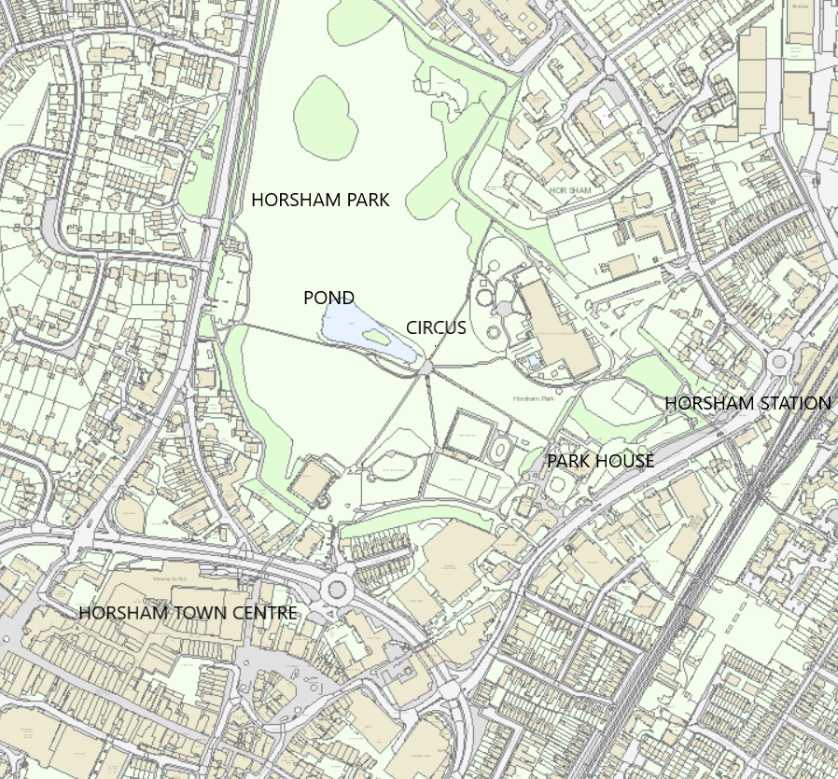

Sculpture Location Plan

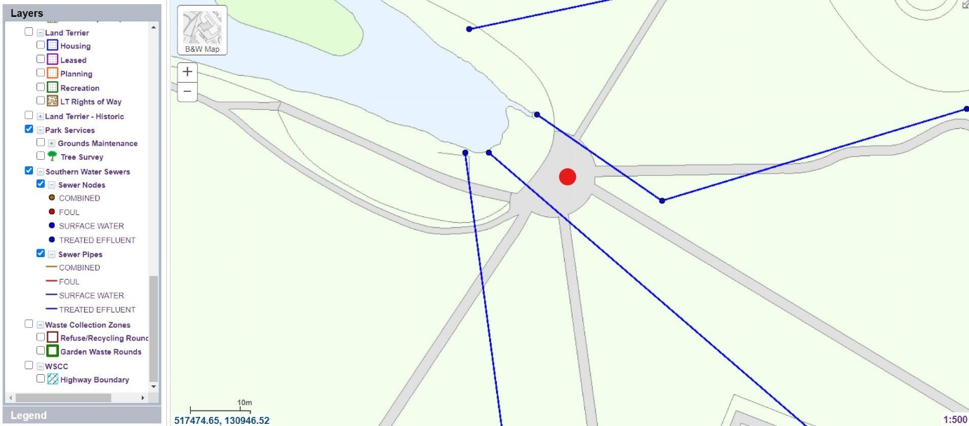
Red Dot: Sculpture location
Blue Lines: Surface water sewer pipes

Satellite View

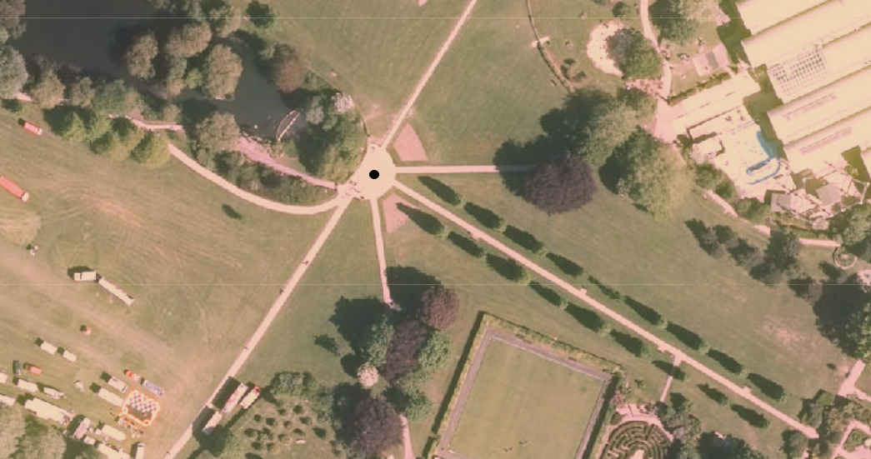

Attachment B: Contextual Photographs

From Park House showing Sensory Garden and avenue towards the ‘Circus’ and pond

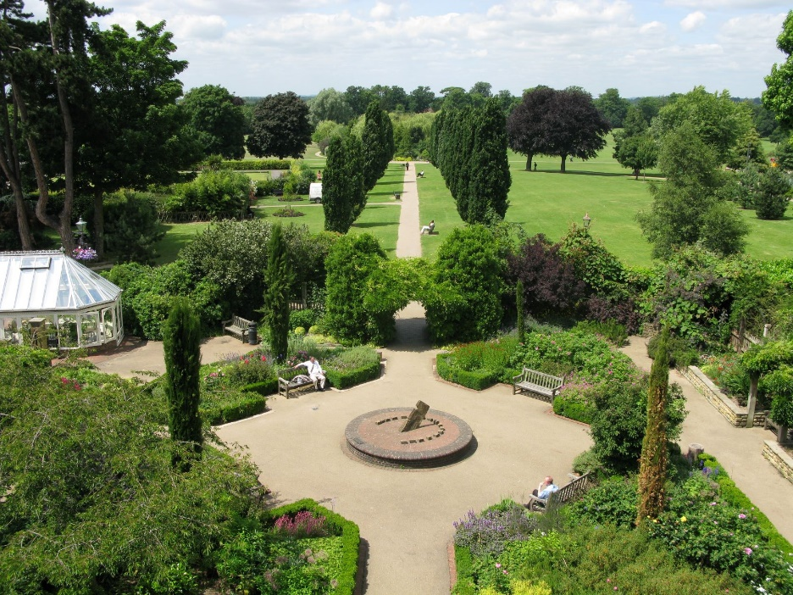

From the ‘Circus’ towards Park House